# MINNESOTA SEX OFFENDER PROGRAM

## AFSCME LABOR/MANAGEMENT MEETING

St. Peter – HR Conference Room – Microsoft Teams  
Thursday June 12th, 2025  
12:00 p.m. – 2:00 p.m.

### Present:

Eric Christensen; Michelle Sexe; Eric Manriquez; Tim Lokensgard; Bonnie Wold; Steaed Doehring; Ryan Cates; Marie Hartman; Suzanne Kocurek; April Forse; Eric Hesse; Gary Tollefson; Teri Hable; Nikki Boder; Heidi Peura

**Reflections/Celebrations:**

## Thanks to all staff for their hard work during the recent elopements from CPS.

## Thanks to the Sunrise staff for their patience with the noise levels during demolition.

## FOLLOW-UP ITEMS

### Vacancy Rates:

|  |  |
| --- | --- |
| AFSCME Overall | 11.8% - *Previous Month 13%* |
| Saint Peter Overall | 15.5% - *Previous Month 14.9%* |
| Security Counselor | 12.5% - *Previous Month 15%* |
| Security Counselor Lead | 3.3% -*Previous Month 3.3%* |
| Health Services SP | % - *Previous Month 41%* |
| Health Services CPS | % - *Previous Month 0%* |

### Security Counselor Vacancy Rates by Watch:

|  |  |
| --- | --- |
| 1st Watch | 2% - *Previous Month 2%* |
| 2nd Watch | 2% - *Previous Month 3%* |
| 3rd Watch | 7% - *Previous Month 13%* |

### 7 new Security Counselors started in June, and 3 new staff are scheduled to start in July.

### Inverse Numbers – Operations & Health Services:

|  |  |
| --- | --- |
| Operations Total | 1915.25 Hours -*Previous Month 469 Hours* |
| 1st Watch Staff inversed into 2nd Watch | 140 Staff for 758.5 Hours |
| 2nd Watch Staff inversed into 3rd Watch | 99 Staff for 514.75 Hours |
| 3rd Watch Staff inversed into 1st Watch | 89 Staff for 642 Hours |
| Health Services SP | 2 Hours |
| Health Services CPS | 0 Hours |

### Overtime Numbers – Operations & Health Services:

|  |  |
| --- | --- |
| Operations Total | 6607.25 Hours - *Previous Month 3894.75* |
| Health Services SP | 24 Hours |
| Health Services CPS | 5.75 Hours |

### Can we start getting the overtime numbers by watch?

### TL: Yes, I will work on that.

### Construction Updates - CPS:

**MS:** Demolition at Sunrise should be finished tomorrow. 18-month timeline.

### Sick Leave Line for SCs:

**MH:** Testing has started, it is on the OD phone.

1. **Galls Uniforms and Allotment:**

**MS:** As discussed last month, due to concerns of pseudo uniforms on outings, we will not be moving forward with polos at CPS.

**AFSCME:** Could the clothing allotment be increased? Galls prices have gone up.

**MH:** I am working with Galls to get a list of the price increases. Kyle Albrecht is the uniform contact person.

### Perimeter Wheelchairs:

**TL:** 2 new wheelchairs have been put into service; we have one more in the box still.

### HR on Campus:

**TH:** We will be following the mandate. MSOP Labor HR staff will not be on campus, due to living outside the radius.

**AFSCME:** Reiterated that we think it would be beneficial to have HR on campus for a variety of reasons.

### Mop Drying:

**This was discussed at the Safety Committee Meeting, as long as the door to the room where the mops are being dried remains shut, the ventilation system in the building will take care of any potential airborne hazards.**

### GAW Staff Lockers/Cupboards:

**MS:** Maintenance has not been able to identify an option that will not destroy the wood. We can discuss this more during the CPS monthly meeting.

### Refrigerator in Radio Room:

**TL:** There is not electrical capacity in that room for a refrigerator.

## MANAGEMENT AGENDA ITEMS

### Thanks for all the employees hard work during the recent elopements from CPS:

**MS:** I appreciate all the hard work, everyone stepped up and had a good attitude during this difficult situation. I want to thank everyone for their teamwork.

### Thanks to the Sunrise staff for the tolerance of the noise levels during construction demolition:

**MS:** I know that it has been very loud in the SRE unit station with the jackhammering, that part of the demo should be completed. I want to thank the staff for their patience during this time.

### CPS policy updates and at need revisions:

**MS:** CPS is looking at all our Policies/Practices, Leads have been encouraged to provide feedback to their supervisors for improvements.

### Johnson Hall Demo set for July -> September:

**EC:** The Demo plan has been finalized for Johnson Hall, it will start in July, and they will be using the back road that goes to 169.

### DHS/DCT Split – behind the scenes work continues and expected to occur without notice/impact to you, (payroll, email, pathlore etc.):

**PTR Transactions and Bidding will be paused 6/10 - 6/24**

* + Beginning Tuesday, June 10, through Monday, June 23, Human Resources will not be able to post jobs for bid.
  + New bid postings will resume on Tuesday, June 24, or later, once the new system is live.
  + HR systems tied to PTR will be offline, which may cause temporary delays in processing personnel transactions.

### See DHS homepage announcements on:

### Payroll deadlines earlier due to holidays in June (19th) and July (4th).

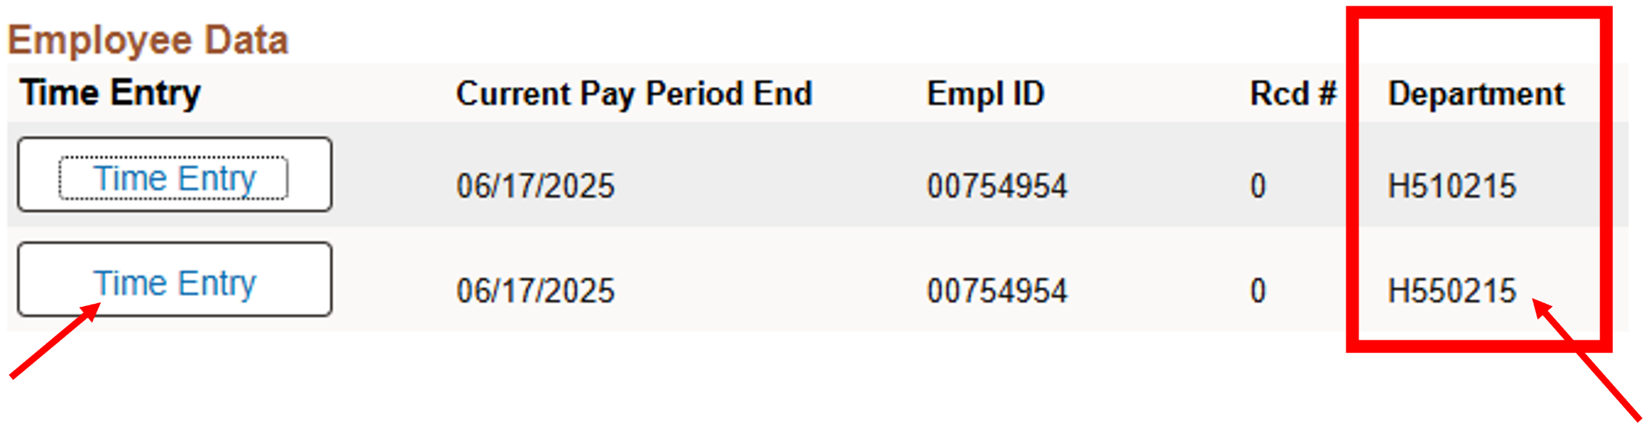

Please be sure to select the Department that begins with **H55** as indicated above.

Additionally, because of upcoming holidays, there are some deadline changes for time entry purposes.

**Also, for the pay period ending June 17, 2025:**

Self Service time entry **MUST** be completed, approved by supervisors and submitted to Payroll Services (loaded) with no error **no later than Monday, June 16, 2025, at noon for ALL DCT Departments.**

### b. Blackout period for June 17-30th for deferred Comp Plan.

We are switching companies so there will be a blackout period.

## AFSCME AGENDA ITEMS

### Radio Issues:

**AFSCME:** There have been reports from members thatsome of the (Man Down) buttons are not working correctly in control center, and some of the radios are mislabeled in the control center. **Staff are strongly encouraged to write reports for these issues to ensure follow-up.**

**TL:** I will follow up with Jesse Miller.

### Camera Issues:

**AFSCME:** After the camera upgrade, the cameras are responding very slow/choppy/frozen in the control centers.

**EC:** This was not anticipated with the camera upgrade; we are working with LVC on getting a quote for upgrading the Matrix. The camera system is recording during the lag.

**BW:** Security is a priority.

### Admission Inconsistencies:

**AFSCME:** Concerns about our Admissions Policy not being followed, such as Admissions happening after hours/weekends when professional staff are not here. Can we do anything about this?

**BW:** We share the frustration and continue to work on this, we are required to follow the court orders, so that makes things difficult.

### Overtime to Other Classes at Point of Inverse:

**AFSCME:** Members have asked about the possibility of allowing other classes working OT at the point of inverse. There are a lot of burned-out staff.

**BW/MS:** We understand, we should be back to normal staffing soon.

### CPS Incidents and Response:

**AFSCME:** Front line staff are the only ones on leave, after critical incidents it always seems the focus is on the direct care staff. They are not the ones that make policies/procedures. When an Emergency of this caliber happens, shouldn’t it be “*all hands-on deck*”?

**MS:** This was an unprecedented incident; CPS has been open since 2008 and we had 2 incidents in a short period of time. We understand that staff are burned out with inversing, and we are getting closer to scaling back the increased staffing. We are looking into additional security procedures.

**BW:** We are taking this very seriously and we have a duty to keep the public safe, there was a need for the extra security.

**GT:** We are looking at all viable options for our GPS needs.

### ADD ON

### Staff Assault:

**AFSCME:** Direct care staff are upset and don’t understand why there wasn’t an AR placement after staff was assaulted. Where is the IOD information located for staff after an incident?

**BW:** We are reviewing the reports, the initial reports/documents did not have all the information.

**MH:** The OD office has the IOD information for staff. I can get a copy of that information. *Please send that information to Eric, Steaed, and Nick.*